Preparing a stained wet mount
Unjumbled the following steps
Cut out the following mixed up steps and paste in the correct order into your notebook. If unsure check you have the correct sequence of letters with your teacher or on my website (there is a pic beside this Learning Goal) before you glue them in.
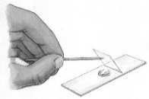 |  | 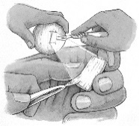 |  | 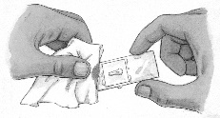 |  | 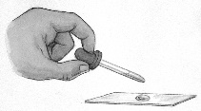 |  | 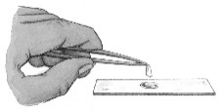
Lower a coverslip over the onion skin and water droplet. |  | Peel a section of onion epidermis. |  | Soak up excess water with a tissue. |  | Add a drop of water to a microscope slide. |  | Place onion skin in drop of water on the slide.
Number each of the steps from 1 to 5.
Staining cells
2. It is much easier to see the internal structure of cells by staining the cells. Staining is usually done with either Methylene blue or Iodine.
(a) In which of the steps listed above (1 to 5) would you use the staining solution?

(b)The drawings below left and right were made of the stained onion cells.
(i) Methylene blue - the nucleus and cell walls take up the methylene blue stain. Use a light blue pencil to colour these components in the drawing below.  (ii) Use the scale to estimate the length and greatest width of a cell in the pic below. | (iii) Iodine - the experiment was repeated with iodine stain, which strongly stains starch grains a deep blue-black colour. Use coloured pencils to colour the starch grains, which are scattered in the cytoplasm in the picture below.
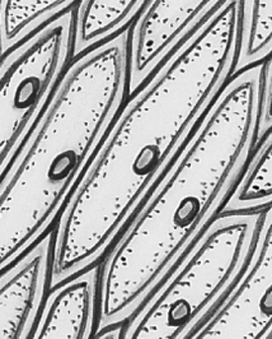
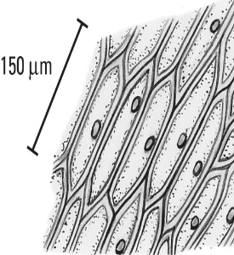

Preparing a stained wet mount
Unjumbled the following steps
Cut out the following mixed up steps and paste in the correct order into your notebook. If unsure check you have the correct sequence of letters with your teacher or on my website (there is a pic beside this Learning Goal) before you glue them in.
Lower a coverslip over the onion skin and water droplet. |  | Peel a section of onion epidermis. |  | Soak up excess water with a tissue. |  | Add a drop of water to a microscope slide. |  | Place onion skin in drop of water on the slide.
Number each of the steps from 1 to 5.
Staining cells
2. It is much easier to see the internal structure of cells by staining the cells. Staining is usually done with either Methylene blue or Iodine.
(a) In which of the steps listed above (1 to 5) would you use the staining solution?

(b)The drawings below left and right were made of the stained onion cells.
(i) Methylene blue - the nucleus and cell walls take up the methylene blue stain. Use a light blue pencil to colour these components in the drawing below.  (ii) Use the scale to estimate the length and greatest width of a cell in the pic below. | (iii) Iodine - the experiment was repeated with iodine stain, which strongly stains starch grains a deep blue-black colour. Use coloured pencils to colour the starch grains, which are scattered in the cytoplasm in the picture below.

